Hospital Management System (HMS)

Software Used
- Java: JDK 8 or higher for core application development and GUI implementation (Swing assumed, replace with JavaFX if applicable).
- SQL Database: MySQL (assumed, replace with SQLite or other if used) for persistent data storage.
- JDBC Driver: MySQL Connector/J (e.g., mysql-connector-java-8.0.x.jar) for database connectivity.
- Development Tools: Notepad for coding, Command Prompt for compilation and execution.
- Optional Tools: MySQL Workbench or DBeaver for database management, Eclipse/IntelliJ for debugging (if used).

Description
The Hospital Management System (HMS) is a robust Java-based application designed to automate and streamline hospital operations. Initially developed as a console-based system, it has been enhanced with a graphical user interface (GUI) for improved usability and a SQL database for persistent data storage. The HMS supports four user roles—Admin, Receptionist, Staff, and Patient—enabling tasks such as user authentication, appointment scheduling, medical record management, and task logging. Built with object-oriented programming (OOP) principles, the system ensures modularity, scalability, and maintainability. It addresses the inefficiencies of manual hospital management by providing a secure, user-friendly, and data-driven solution.
The project is structured under C:\JJava\Jjavaprograms\comhms\src, with 26 core Java files across packages (com.hms.auth, com.hms.admin, com.hms.staff, com.hms.reception, com.hms.patient) and additional files for GUI and SQL integration. It leverages MVC (Model-View-Controller) architecture, with utility classes for captcha validation, task logging, and medical record formatting.
Screenshot Opportunity: Include a screenshot of the main GUI dashboard (e.g., login screen or patient dashboard) here to visually introduce the system’s interface.

Features
- User Authentication: Secure login with captcha verification and audit logging for all roles.
- Admin Role:
  - Manage hospital schedules (e.g., doctor availability).
  - Assign staff to schedules.
- Receptionist Role:
  - Book and cancel appointments.
  - Register new patients.
  - View and log tasks (e.g., appointment confirmations).
- Staff Role:
  - View assigned schedules and tasks.
  - Access patient appointment details (for doctors/nurses).
- Patient Role:
  - View booked appointments and schedules.
  - Access medical records in detailed, summary, or patient-friendly formats.
- GUI Interface: Intuitive graphical interface for all user interactions, replacing console menus.
- SQL Integration: Persistent storage for users, appointments, medical records, and schedules.
- Utility Functions:
  - Captcha validation for secure login (CaptchaValidator).
  - Task logging for receptionist actions (ReceptionTaskLogger).
  - Formatted medical record outputs (MedicalRecordFormatter).
Screenshot Opportunity: Add screenshots of key features, such as:
- Login screen with captcha.
- Patient dashboard showing medical records.
- Receptionist appointment booking interface.
- Task log view.

Requirements

Hardware
- PC with at least 4GB RAM and 500MB free disk space.
- Windows OS (or compatible OS with Java support).

Software
- Java Development Kit (JDK): Version 8 or higher (verify with java -version).
- MySQL Server: Version 5.7 or higher (or SQLite if used).
- JDBC Driver: MySQL Connector/J (download from MySQL website).
- Command Prompt: For compilation and execution.
- Optional: MySQL Workbench for database visualization.

Dependencies
- Include the JDBC driver in the classpath (e.g., mysql-connector-java-8.0.x.jar).
- Ensure Java and MySQL are added to the system PATH environment variable.
Screenshot Opportunity: Include a screenshot of the Command Prompt showing java -version and mysql --version to confirm software setup.

Database Setup
Follow these steps to set up the MySQL database for HMS:
- Install MySQL:
  - Download and install MySQL Community Server from MySQL website.
  - Configure with a root user and password (e.g., root/password).
- Create Database:
  - Open MySQL command line or Workbench.
Execute:
Create database hospital_management_system;
USE hospital_management_system;
- Create Tables:
Run the following SQL commands to create core tables (modify if using SQLite or different schema):
CREATE TABLE Users (
user_id INTEGER PRIMARY KEY AUTO_INCREMENT,
username VARCHAR(50) NOT NULL UNIQUE,
password VARCHAR(255) NOT NULL,
name VARCHAR(100) NOT NULL,
age INTEGER CHECK (age >= 0),
role ENUM('ADMIN', 'DOCTOR', 'RECEPTIONIST', 'STAFF', 'PATIENT') NOT NULL
);

CREATE TABLE Patients (
patient_id VARCHAR(10) PRIMARY KEY,
user_id INTEGER NOT NULL UNIQUE,
gender VARCHAR(20) NOT NULL,
contact VARCHAR(10) NOT NULL CHECK (LENGTH(contact) = 10 AND contact REGEXP '^[0-9]+$'),
medical_history TEXT,
FOREIGN KEY (user_id) REFERENCES Users(user_id) ON DELETE CASCADE
);

CREATE TABLE Doctors (
doctor_id VARCHAR(10) PRIMARY KEY,
user_id INTEGER NOT NULL UNIQUE,
specialization VARCHAR(100) NOT NULL,
contact VARCHAR(10) NOT NULL CHECK (LENGTH(contact) = 10 AND contact REGEXP '^[0-9]+$'),
FOREIGN KEY (user_id) REFERENCES Users(user_id) ON DELETE CASCADE
);

CREATE TABLE Receptionists (
receptionist_id VARCHAR(10) PRIMARY KEY,
user_id INTEGER NOT NULL UNIQUE,
desk_id VARCHAR(10) NOT NULL UNIQUE,
FOREIGN KEY (user_id) REFERENCES Users(user_id) ON DELETE CASCADE
);

CREATE TABLE Staff (
staff_id VARCHAR(10) PRIMARY KEY,
user_id INTEGER NOT NULL UNIQUE,
department VARCHAR(100) NOT NULL,
FOREIGN KEY (user_id) REFERENCES Users(user_id) ON DELETE CASCADE
);

CREATE TABLE Appointments (
appointment_id VARCHAR(10) PRIMARY KEY,
patient_id VARCHAR(10) NOT NULL,
doctor_id VARCHAR(10) NOT NULL,
time_slot VARCHAR(50) NOT NULL,
is_emergency BOOLEAN NOT NULL DEFAULT FALSE,
follow_up_due_date VARCHAR(50),
follow_up_notes TEXT,
FOREIGN KEY (patient_id) REFERENCES Patients(patient_id) ON DELETE CASCADE,
FOREIGN KEY (doctor_id) REFERENCES Doctors(doctor_id) ON DELETE CASCADE
);

CREATE TABLE BillItems (
bill_item_id INTEGER PRIMARY KEY AUTO_INCREMENT,
appointment_id VARCHAR(10) NOT NULL,
description TEXT NOT NULL,
cost DECIMAL(10, 2) NOT NULL CHECK (cost >= 0),
FOREIGN KEY (appointment_id) REFERENCES Appointments(appointment_id) ON DELETE CASCADE
);

CREATE TABLE AuditLogs (
log_id INTEGER PRIMARY KEY AUTO_INCREMENT,
user_id INTEGER,
log_message TEXT NOT NULL,
timestamp DATETIME DEFAULT CURRENT_TIMESTAMP,
FOREIGN KEY (user_id) REFERENCES Users(user_id) ON DELETE SET NULL
);

- Insert Sample Data:
Add initial data for testing:
INSERT INTO users (user_id, username, password, role, name, age)
VALUES (1, 'admin1', 'Admin@2023', 'Admin', 'Alice Brown', 40),
(4, 'recep1', 'Recep@2023', 'Receptionist', 'Bob Wilson', 30),
(5, 'patient1', 'Pat@2023', 'Patient', 'John Smith', 30);

INSERT INTO patients (patient_id, user_id, medical_history)
VALUES ('PAT001', 5, 'Diabetes, Hypertension');

INSERT INTO appointments (appointment_id, patient_id, schedule_id, status, purpose, notes)
VALUES (1, 'PAT001', 1, 'Confirmed', 'Medical Consultation', 'Routine checkup');

INSERT INTO medical_records (record_id, patient_id, diagnosis, treatment, record_date, appointment_id)
VALUES (1, 'PAT001', 'Type 2 Diabetes', 'Metformin 500mg daily', '2025-05-04 01:00:23', 1);

INSERT INTO schedules (schedule_id, staff_id, start_time, end_time, status)
VALUES (1, 'STF001', '2025-05-04 09:00:00', '2025-05-04 10:00:00', 'Available');

- Configure JDBC:
  - Place the JDBC driver (e.g., mysql-connector-java-8.0.x.jar) in C:\JJava\Jjavaprograms\comhms\lib.
Update your Java code (e.g., DatabaseManager.java) with connection details:
String url = "jdbc:mysql://localhost:3306/hms_db";
String user = "root";
String password = "password";

Screenshot Opportunity: Include screenshots of:
- MySQL Workbench showing the hms_db tables.
- Query execution output (e.g., SELECT * FROM users).
- JDBC connection success message in the GUI or console.

Schema
The database schema consists of the following entities and relationships:
- Tables:
  - users: Stores user details (ID, username, password, role, name, age).
  - patients: Links patients to users, includes medical history.
  - appointments: Records appointment details (ID, patient, schedule, status).
  - medical_records: Stores patient medical records (diagnosis, treatment, date).
  - schedules: Manages staff schedules (ID, staff, time, status).
- Relationships:
  - One users to one patients (via user_id).
  - One patients to many appointments (via patient_id).
  - One patients to many medical_records (via patient_id).
  - One appointments to one medical_records (via appointment_id).
  - One schedules to many appointments (via schedule_id).
- Keys:
  - Primary: user_id, patient_id, appointment_id, record_id, schedule_id.
  - Foreign: user_id in patients, patient_id and appointment_id in medical_records.
Screenshot Opportunity: Add an ER diagram screenshot (e.g., from MySQL Workbench) showing tables, relationships, and keys.

Compilation Instructions
Navigate to the project directory:
cd C:\JJava\Jjavaprograms\comhms\src

- Ensure the JDBC driver is in the classpath (e.g., C:\JJava\Jjavaprograms\comhms\lib).
Compile all Java files, including GUI and SQL utilities:
javac -cp ".;../lib/mysql-connector-java-8.0.x.jar" com/hms/Main.java com/hms/auth/model/UserLogin.java com/hms/auth/model/AuditLog.java com/hms/auth/view/LoginView.java com/hms/auth/controller/UserLoginService.java com/hms/auth/util/CaptchaValidator.java com/hms/auth/util/DashboardRouter.java com/hms/admin/model/Admin.java com/hms/admin/model/Schedule.java com/hms/admin/view/AdminView.java com/hms/admin/controller/AdminService.java com/hms/staff/model/Staff.java com/hms/staff/model/ClinicalStaff.java com/hms/staff/model/Doctor.java com/hms/staff/model/Nurse.java com/hms/staff/view/StaffView.java com/hms/staff/controller/StaffService.java com/hms/reception/model/Receptionist.java com/hms/reception/model/Appointment.java com/hms/reception/view/ReceptionView.java com/hms/reception/controller/ReceptionService.java com/hms/reception/util/ReceptionTaskLogger.java com/hms/patient/model/Patient.java com/hms/patient/model/MedicalRecord.java com/hms/patient/view/PatientView.java com/hms/patient/controller/PatientService.java com/hms/patient/util/MedicalRecordFormatter.java
- If new GUI/SQL files exist (e.g., LoginFrame.java, DatabaseManager.java), add them to the command:
javac -cp ".;../lib/mysql-connector-java-8.0.x.jar" com/hms/Main.java ... com/hms/DatabaseManager.java com/hms/gui/LoginFrame.java
- Screenshot Opportunity: Include a screenshot of the Command Prompt showing successful compilation (e.g., no errors after javac).

Execution Instructions
Ensure the MySQL server is running:
- mysql -u root -p
- Verify the database hms_db and tables are set up.
- Run the HMS application:
java -cp ".;../lib/mysql-connector-java-8.0.x.jar" com.hms.Main
- Interact with the GUI:
  - Login as patient1 (password: Pat@2023) for patient features.
  - Use recep1 (password: Recep@2023) for receptionist tasks.
  - Try admin1 (password: Admin@2023) for admin functions.

Author Details
- Name: Syed Usman. Adarsh Kumar Singh
- Institution: Vidyashilp University
- UEN : 2023UG000180 , 2023UG000172
- Date: 06 May 2025

Additional Notes
- Troubleshooting:
  - Compilation Errors: Verify file paths, ensure all 26+ files exist, check JDBC driver in classpath.
  - Database Errors: Confirm MySQL server is running, check connection URL/user/password.
  - GUI Issues: Ensure Java version supports GUI framework (e.g., Swing requires JDK 8+).
- Project Structure:
  - Source: C:\JJava\Jjavaprograms\comhms\src\com\hms
  - Libraries: C:\JJava\Jjavaprograms\comhms\lib
- Future Enhancements:
  - Add mobile app support.
  - Implement cloud-based storage.
  - Integrate advanced analytics for hospital performance.

Structure:
C:\JJava\Jjavaprograms\comhms\src\com\hms
├── auth\model
│ ├── UserLogin.java
│ └── AuditLog.java
├── auth\view
│ └── LoginView.java
├── auth\controller
│ └── UserLoginService.java
├── auth\util
│ ├── CaptchaValidator.java
│ └── DashboardRouter.java
├── admin\model
│ ├── Admin.java
│ └── Schedule.java
├── admin\view
│ └── AdminView.java
├── admin\controller
│ └── AdminService.java
├── staff\model
│ ├── Staff.java
│ ├── ClinicalStaff.java
│ ├── Doctor.java
│ └── Nurse.java
├── staff\view
│ └── StaffView.java
├── staff\controller
│ └── StaffService.java
├── reception\model
│ ├── Receptionist.java
│ └── Appointment.java
├── reception\view
│ └── ReceptionView.java
├── reception\controller
│ └── ReceptionService.java
├── reception\util
│ └── ReceptionTaskLogger.java
├── patient\model
│ ├── Patient.java
│ └── MedicalRecord.java
├── patient\view
│ └── PatientView.java
├── patient\controller
│ └── PatientService.java
├── patient\util
│ └── MedicalRecordFormatter.java
└── Main.java

Screenshot:
Output:
Login interface:
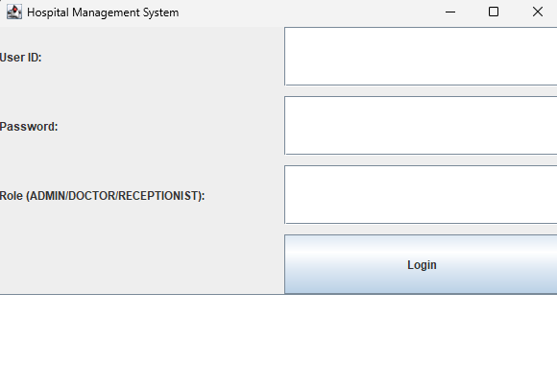
Options:
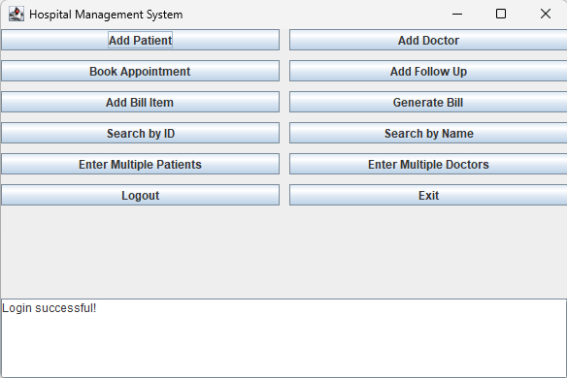

Option 1:Adding patient
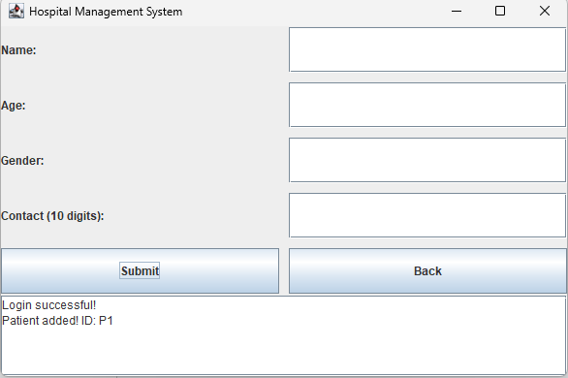

Patient and Doctor Added:
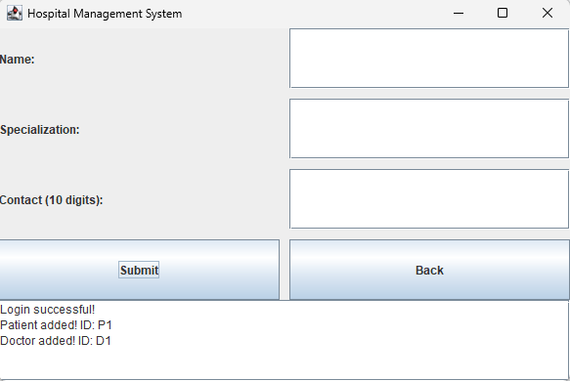

Booking appointment:
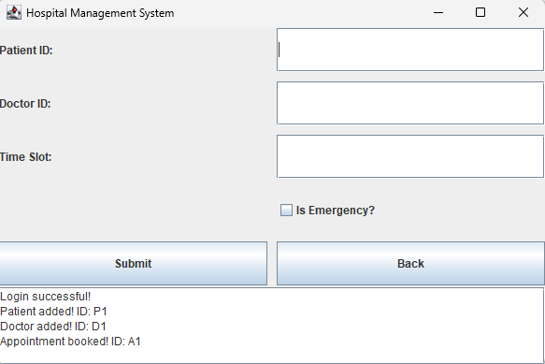

Add follow up:
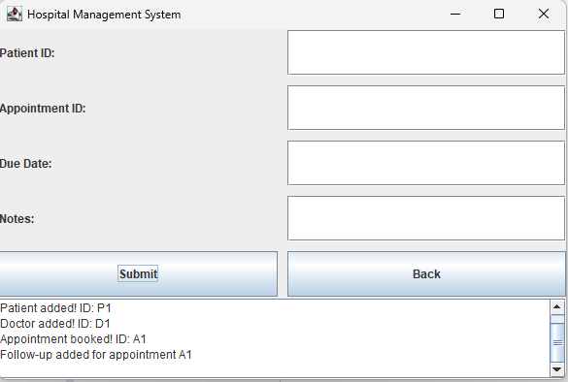

Add Bill Item:
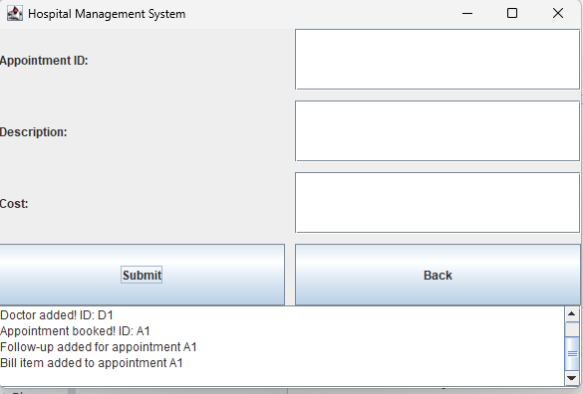

Generate Bill:
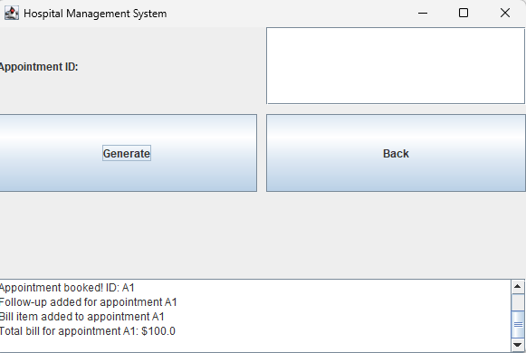

Search By Id:
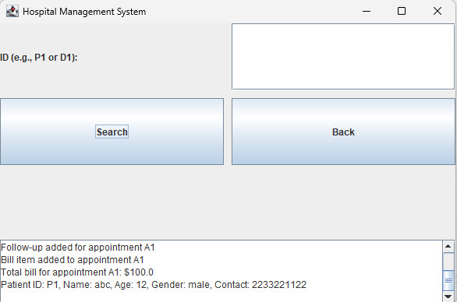

Search By Name:
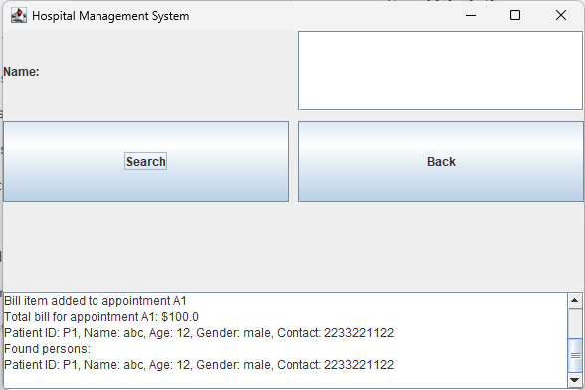

Enter Multiple Patients:
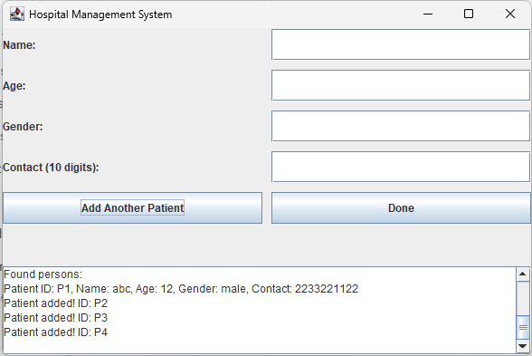

Enter Multiple Doctors:
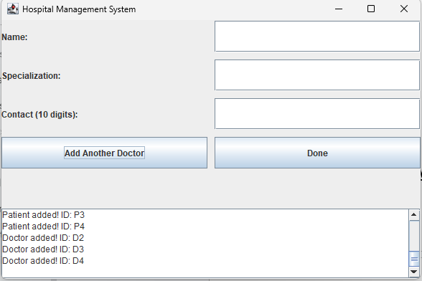

Logout:
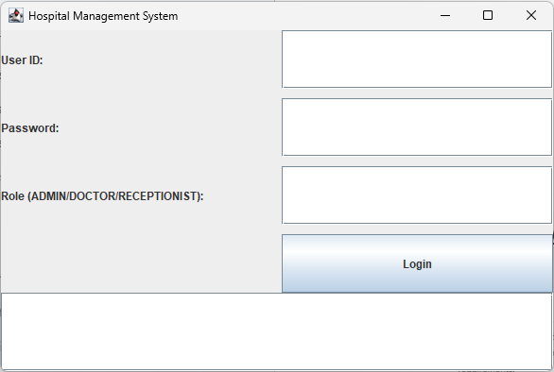

SQl Output:
1.SELECT * FROM Users ;
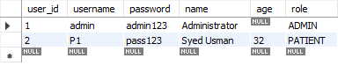
2.SELECT * FROM Patients p JOIN Users u ON p.user_id = u.user_id;

